EIBA CONFERENCE
POLITECNICO DI MILANO
Milan, 14-16 DECEMBER 2017
Hotel Palazzo delle Stelline
Corso Magenta 61
Please fill the following reservation form and send it through e-mail or telefax at the Hotel, in order to confirm your reservation before the 31st October 2017.
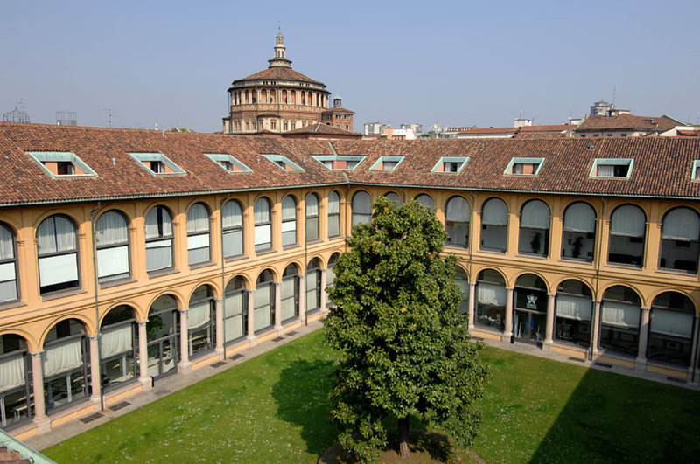
Hotel Palazzo delle Stelline- Milano
Corso Magenta, 61 - 20123 Milano - Italy
Tel. (+39) 02 48 18 431 Fax. (+39) 02 48 19 42 81
www.hotelpalazzostelline.it
email. info@hotelpalazzostelline.it

ROOMS RESERVATION
Please confirm the following reservation:
Arrival date: _______________________________ (Check-in starting from 14.00)
Departure date: _______________________________ (Check-out until 12.00)

N° ________ superior single room at €. 110,00/night (buffet breakfast included
N°_________double room single use (DUS)€. 135,00/night (buffet breakfast included)
N°_________twin/double room €. 155,00/night (buffet breakfast included)
N°__________ deluxe suite room at €. 175,00/night (buffet breakfast included)
N°__________ suite room at €. 165,00/night (buffet breakfast included)
Extra bed €40/night available only in standard twin/double room and suites
Please note that there is a limited number of rooms booked for each category, therefore those who book in advance will be privileged.

Name and address:__________________________________________________________________________
Address: ____________________________________________________________________________________
City/Town:__________________________________________________________________________________
Phone number:____________________________ Fax number: __________________________________
Credit card: _____________________________________________ Expiry date: _____________________
Signature: ___________________________________________________________________________________

Note well: the above-mentioned reservation is guaranteed. The cancellation over the deadline or the no show will involve a 100% charge of the agreed rate for the room. In case you need to amend or cancel the reservation, we kindly ask you to do it within 8 days before your arrival.

Hotel Confirmation:
________________________________________________________________________________________________
(date, stamp, signature)

